Introduction

*What is a Mutual Fund?*

A mutual fund is a professionally managed investment scheme which pools funds in a large number of investors who share a common financial goal. The money is invested in a diversified portfolio of stocks, bonds, money market instruments, or other securities. Units are issued to the investors in proportion to their investment, and the units' value is determined by the Net Asset Value (NAV), i.e., the market value of the assets minus the charges. Mutual funds are suitable for those who don't have big amounts to invest or the expertise to analyze the market but want to grow their wealth. The investments are made by the fund manager depending upon the scheme's objective, and the charges are regulated by SEBI.

Mutual funds provide a wide range of investment opportunities suitable for different financial objectives like retirement, children's education, or purchasing a house. Even with a high saving rate, ignorance has prevented mutual funds from becoming popular relative to conventional schemes like fixed deposits and gold. Mutual funds, nonetheless, provide an easy means for retail investors to avail themselves of market appreciation. To maximize returns, investors must diversify across equity, debt, and gold funds and choose according to their risk appetite and horizon. Right advice or due diligence would assist in the choice of the best fund, thereby making mutual funds an easy and effective investment channel.

*Types of Mutual Funds:*

1. **Large-Cap Funds** – Invest primarily in large, blue-chip stocks (top 100 by market cap). They are stable, low-risk, and provide good long-term returns.
2. **Mid-Cap Funds** – Focus on mid-cap stocks (101 to 250 by size). The funds provide higher growth potential than large-cap funds but with moderate risk.
3. **Small-Cap Funds** – Invest in smaller-sized companies (excluding top 250 market-cap ones). Small-cap funds hold the maximum opportunity to increase in size but maximum potential and highest level of risk and volatility as well
4. **Multi-Cap Funds** – Invest in large-cap, mid-cap, and small-cap stocks but maintain a diversified portfolio. As per SEBI guidelines, these funds are required to invest a minimum of 25% in each large-, mid-, and small-cap stock.
5. **Flexi-Cap Funds** – Similar to multi-cap funds but with complete freedom to invest in any proportion in large-, mid-, and small-cap stocks based on market conditions and fund manager's strategy.

Methodology

*Standard Deviation and Probability Distribution in Mutual Fund Investment*

Standard Deviation:

In mutual funds, standard deviation is applied to calculate the volatility of the fund's returns for a specified time period. The greater the standard deviation, the greater the volatility of the fund's returns, i.e., the riskier the fund. For example, an equity mutual fund will be more standard deviation-prone due to the volatility of the share market, and a debt fund will be less standard deviation-prone with more stable returns. Investors use standard deviation to calculate the risk measure of a mutual fund and determine whether it is acceptable within their risk threshold.  
  
Probability Distribution:

This concept addresses all the returns an investment may have and how likely they are to happen. It tells an investor the prospective returns and potential risk of a mutual fund. For instance, under a standard distribution (bell-shaped curve), most of the returns will occur around the middle, with lesser occurrences of severe gains or losses. If there is a probability distribution that leans in one way, then that may indicate additional instances of huge returns—good or bad. Probability distribution makes it easier for an investor to predict the anticipated performance of a fund under specific market conditions.  
  
By applying standard deviation as well as probability distribution analysis, investors can make well-informed decisions regarding which mutual funds are most suitable for their financial objectives and risk tolerance.

Canara Robeco Bluechip Equity Fund

*Why have I chosen this mutual fund?*

I have chosen Canara Robeco Bluechip Equity Fund - Regular Plan - Growth, as this fund may be appropriate for my investment goal:

1. Large-Cap Stability & Growth Potential

* This fund invests primarily in large-cap stocks, large, well-established companies with solid finances and less volatility than mid- and small-cap funds.
* It offers stable long-term growth with minimal risk compared to other equity funds.

1. Reliable Performance & Solid Track Record

* Canara Robeco Bluechip Equity Fund has delivered competitive returns year after year, beating its benchmark (NIFTY 100 Total Return Index) year after year.
* It has endured bear markets and has recovered significantly in bull markets.

1. Professional fund management

* Managed by an experienced team at Canara Robeco Mutual Fund, whose record stands well for rigorous investment practices.
* The fund is actively managed, i.e., it chooses the highest-rated blue-chip shares.

1. Lower Volatility & Risk

* Large-cap mutual funds like this are generally less volatile and risky than mid-cap or small-cap funds and are hence appropriate for moderate-risk investors.
* It has a relatively low standard deviation, which means that its returns are less volatile in the long run.

1. Long-Term Generation of Wealth (Growth Option)

* Since I  have chosen the Growth plan, my earnings will be reinvested rather than paid out as dividends, to enable compounding and long-term capital appreciation.
* Best for long-term investors (5+ years) who are willing to grow their wealth over the long run.

1. Strong Fund House & Lower Expense Ratio

* Canara Robeco Mutual Fund is one of the oldest and most trusted fund houses in India.
* The fund also has a relatively lower cost ratio, so more of your money is invested and grows over time.

*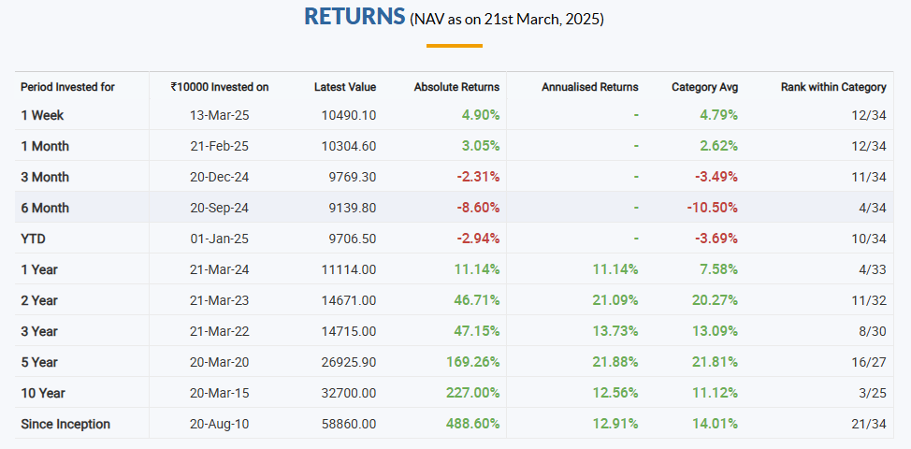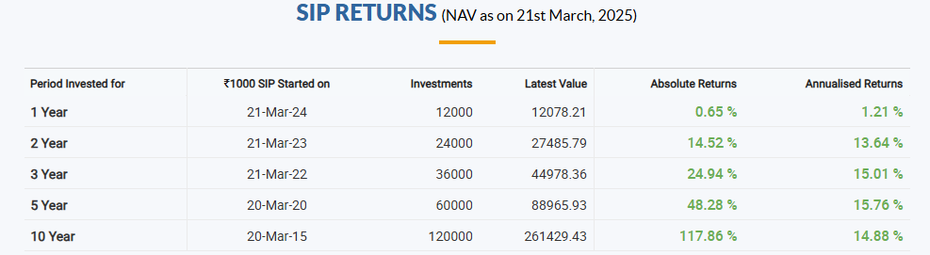Data Collection and Graphical Representation*

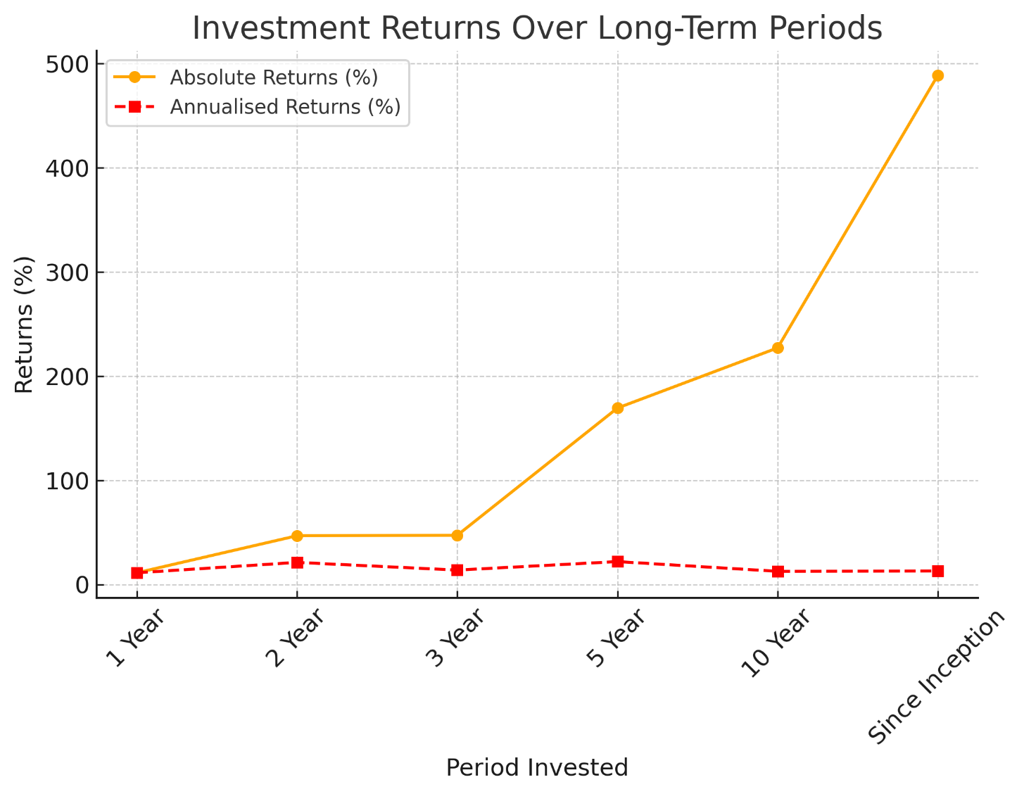

*By grasping the returns on a year-by-year basis, one is able to realize how the fund has worked at different times. Looking at the returns of 1 year, 2 years, 3 years, 5 years, and 10 years as well as since inception, one can understand how its growth capability and reliability are.*

Expected Value Calculation



*Expected Value Calculation*

Expected Value (EV) is your long-term average result you can anticipate if you look at all of the potential results. It assists investors in anticipating probable returns based on historical figures.

*How to Compute Expected Value?*

The expected value formula is:

EV = Σ(Xi * P(Xi))

Where:

• Xi = Possible results (e.g., different returns on investment)

• P(Xi)= Probability of each outcome to occur

*Calculation:*

Measuring Annualized Return remains indefinite since the Moving Average technique is not part of Time Series Analysis. So, we have taken a quantitative method to compute the Expected Value.

Expected Value (EV) = Σ(Xi × P(Xi))

EV = 17.1145

*Reasoning for Determining Probabilities of Occurrence*

The probability of every period's return has been tuned according to the overall risk profile of the fund. As the fund invests in different market segments, the probability of achieving certain levels of return varies. The following points explain why each time period is assigned a particular chance of occurrence:

*1-Year Return 11.14% with 10% probability:*

This could be an instance of relatively low returns, which occurs less frequently, maybe due to unusual unfavourable market conditions.

*2-Year Return 21.09% with 25% probability:*

This is a higher return with a comparatively higher probability, indicating that the market conditions to produce this return are more general or anticipated.

*3-Year Return 13.73% with 20% probability:*

This medium-range return may indicate moderately favorable conditions, which are quite common, though not as common as in the case of higher returns.

*5-Year Return 21.88% with 25% probability:*

This is the best return and has the same probability as that of the 21.09% return, which means that the positive factors contributing to this return are as likely.

*10-Year Return 12.56% with 20% probability:*

This return would best be characterized as comparatively low, but it stands a good chance of occurring, so it must have standard or mixed conditions.

*Conclusion:*

The illustrated probability distribution of returns, as seen in the table, shows a wide range of outcomes based on past experience or expert estimates. The higher probabilities (25%) are assigned to the medium-to-high returns (21.09% and 21.88%), showing an expectation of more frequent instances of favorable market conditions. The lower returns, as seen in rates such as 11.14% and 12.56%, are assigned lower probabilities (10% and 20%, respectively), showing that unfavorable conditions are comparatively less likely to happen.

Generally, the distribution appears to be arranged to fit reasonable expectations, both positive and negative. This provides the investor with the ability to make informed decisions based on the analysis of potential returns against their respective probabilities.

*Risk Analysis:*

Risk analysis is uncertainty related to returns on investment, which can create potential risks. It is an essential process through which investors examine the volatility and predictability of returns. Risk analysis enables the comprehension of how various factors can affect investment performance, thereby enhancing decision-making and risk management measures.

Risk analysis is compared to two forms of returns:

1. *Expected Return* – The expected return on an investment, as calculated by taking the past performance and extrapolating it to estimated returns. This is the weighted average of possible returns, with each possible return being multiplied by the probability of happening.
2. *Realized Return* – The actual return earned over a particular time horizon, indicating the performance of the investment. It can deviate from the projected return because of unexpected market conditions, economic fluctuations, or firm-specific events.

By comparing realized and anticipated returns, investors will be able to see how much they approximated their expectations and the level of risk. Gross differences between the two would be a sign of greater risk and would prompt investors to re-think their approach or diversify their portfolios.

*Risk Categories:*

Investors are faced with various risks in investment alternatives, commonly classified as Systematic Risk and Unsystematic Risk.

1. *Systemic Risk* - Systematic risk is brought about by forces outside that influence the whole market. These risks, which are not controllable, can't be diversified and fall under the realm of the market and affect all investments.

* *Systemic Risk Factors:*

1. *Interest Rate Risk:* The risk that movement in interest rates will negatively impact investment income. Rate increases can lower the value of fixed-income securities.
2. *Market Risk:* Risk of investment losses on account of a decline in the market, precipitated by macroeconomic factors, investor sentiment, or global events.
3. *Purchasing Power Risk:* This is inflation risk, and it lowers the real value of returns when prices rise.
4. *Unsystematic Risk* - Unsystematic risk is firm-specific, industry-specific, or sector-specific and arises due to reasons within a firm. It is minimized through diversification, unlike systematic risk.

* *Unsystematic Risk Components:*

1. *Business Risk:* The likelihood of loss due to operational malfunctions, managerial inefficiencies, supply chain breaks, or worker issues.
2. *Financial Risk:* Risk of instability because of high debt, mismanagement, or insolvency.

*Summary:*

Systematic risk is the risk that impacts the whole market and cannot be diversified, while unsystematic risk is the risk that is particular to some companies or industries and can be reduced by diversification. Both risks must be addressed for a sound investment strategy.

*Risk Measurement with Standard Deviation*

Risk analysis frequently employs standard deviation, a measure of the volatility of investment returns. It quantifies the extent to which actual returns differ from expected returns, enabling investors to assess investment risk.

Formula:

Standard Deviation = √(Variance)​

Where variance (σ²) measures the average of the squared differences from the mean.

*Interpretation:*

* Increased Variability: Has higher risk and return volatility, i.e., actual performance can differ quite widely from expected return. This is typical of high-risk, high-reward investments.
* Lower Standard Deviation: Impplies greater stable and predictable returns in the long term, commonly linked to low-risk investments.

*Significance:*

Investors can analyze asset risk by assessing the standard deviation of return. The metric is essential in making decisions and risk management strategies. It further assists in comparing the risk profile of various investments to select the most appropriate for risk tolerance and financial goals.



Standard Deviation = σ²

= √(ΣP(Xi) * (Xi – X̄)2)

≈ √19.64

≈ 4.43

*Risk Analysis Based on Standard Deviation (4.43%)*

The **standard deviation of 4.43%** measures how much the **Canara Robeco Bluechip Equity Fund - Regular Plan – Growth** deviates from its expected return (**17.1145%**). In simple terms, it helps investors understand whether the fund provides **stable returns** or experiences significant fluctuations over time.

*Implications of This:*

1. *Moderate Volatility:* A standard deviation of 4.43% implies that most of the time, the returns of the fund are in the moderate range about the expected return. That is, the returns are most of the time in the range 12.6845% (17.1145% - 4.43%) and 21.5445% (17.1145% + 4.43%).
2. *Stability Indicator:* The reason why the standard deviation is not very high is that the fund is fairly stable and less prone to having very extreme movements in returns.
3. *Risk Assessment:* The risk level of the fund is moderate, and this may appeal to investors looking for a moderate balance between return potential and exposure to risk.
4. *Consistency of Performance:* Investors can be assured that the fund will achieve a relatively steady performance in the long run with little deviation from the average result.

*Is Canara Robeco Bluechip Equity Fund - Regular Plan - Growth a good investment?*

Investment in the Canara Robeco Bluechip Equity Fund - Regular Plan - Growth depends on your investment style, risk tolerance, and goals. The following are some of the most important features for a smart choice:

*Investment Reasons:*

1. *Moderate Risk, Stable Returns:*

* The standard deviation of the fund is 4.43%, indicating moderate volatility.
* A predicted return of 17.1145% suggests possible high returns and excellent performance.

1. *Bluechip Focus:*

* Being a Bluechip Equity Fund, it invests in stable large-cap stocks.
* They behave predictably during periods of market volatility, bringing some stability during periods of uncertainty.

1. *Growth-Focused:*

* The Growth Plan aims to maximize long-term capital appreciation rather than providing regular dividends.
* Ideal for long-term investors who desire to build wealth.

1. *Strong Historical Performance:*

* Consistent returns over a range of time periods, attractive to moderate and conservative-risk investors.

*Key Factors:*

1. Market Risk:

* The fund faces market risks that can impact returns during downturns, despite moderate volatility.

1. Less Yield in Bear Markets:

* Bluechip funds may trail mid-cap or small-cap funds in bull markets.
* Can be conservative in extremely bullish markets.

1. Expense Ratio:

* Verify the expense ratio of the fund; excessive charges will cut into net returns.

*Conclusion*:

The Canara Robeco Bluechip Equity Fund - Regular Plan - Growth fund is suitable for investors looking for: -

1. Moderate risk with likelihood of consistent returns.
2. Long-term capital appreciation rather than short-term profit.
3. Stability through large-cap investments, suitable for conservative and moderate-risk profiles.

It is not necessarily the best for active investors seeking instant growth or high-risk, high-reward opportunities.

Conclusion

**The Canara Robeco Bluechip Equity Fund - Regular Plan - Growth** is a good investment for individuals looking for long-term capital appreciation with moderate risk exposure. Its standard deviation of 4.43% reflects stable performance with controlled volatility, hence it is good for conservative or moderately aggressive investors.

By investing in large-cap, financially strong companies, the fund aims to earn consistent returns while minimizing the effects of market volatility. Although it will not earn spectacular returns during a market bubble, it provides a balanced growth and risk management approach.

Investors looking for long-term wealth accumulation will find this fund to be a reliable choice. However, similar to any investment, it is crucial to match the risk profile of the fund with individual financial objectives and to regularly review its performance to make informed decisions.